

**Micro Projet**

**Réalisation d'un site web pour l’achat de la musique avec Spring Boot , Maven ,ReactJs ,Material-UI et MySQL .**

**Hmimssa Soufiane**

**2020/2021**

**Objectif :**

Réalisation d'un site web pour l’achat de la musique  l'architecture utilise tout au long du developpement est divise en trois parties.

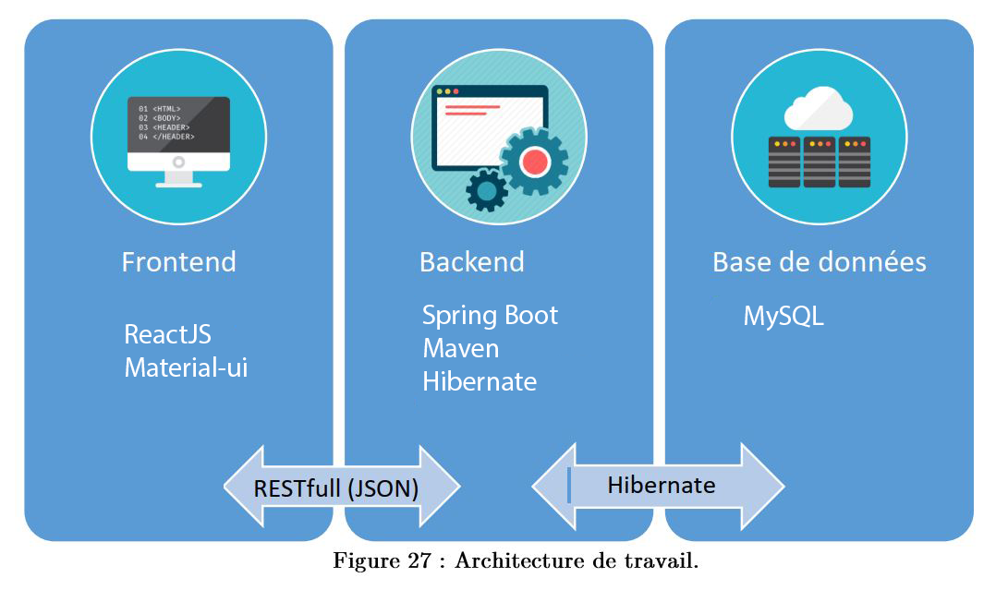

**Les outils de développement utilisés :**

|  |  |
| --- | --- |
| ⮚ Material UI : C:\Users\LENOVO 510\Desktop\logo.png | ⮚ Spring Boot :  C:\Users\LENOVO 510\Desktop\unnamed.png |
| ⮚ ReactJS :  C:\Users\LENOVO 510\Desktop\react.png | ⮚ **MySql :**  C:\Users\LENOVO 510\Desktop\EST ESSAOUIRA\0_vxsZyZXf_IEC0YmE.png |
| ⮚ Hibernate :  C:\Users\LENOVO 510\Desktop\1uNl_IZX.png | ⮚ **Maven:**  C:\Users\LENOVO 510\Desktop\EST ESSAOUIRA\1_qxGkT_JGyTjnoIkWE5sfwg.png |

Notre base de données

Cette base de donne a été générer par **Hibernate**

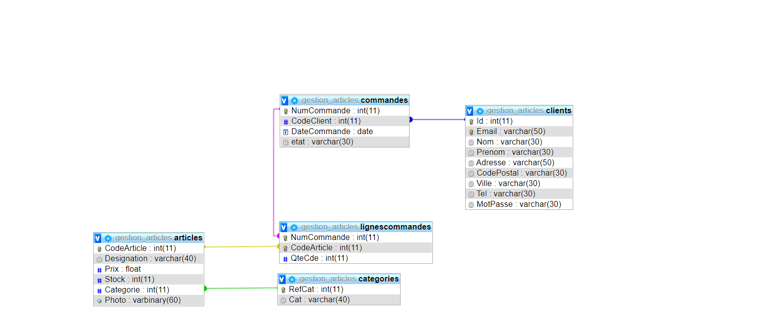

**Structure de Projet Back-end**

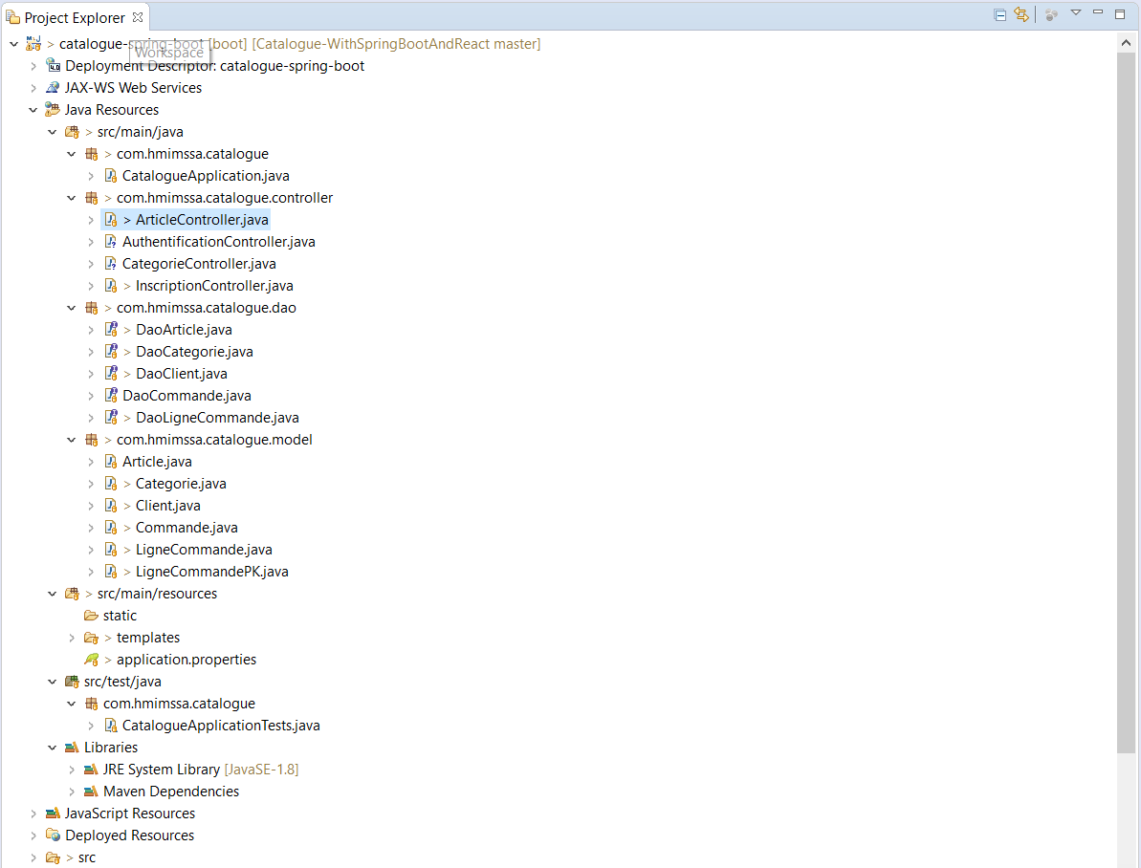

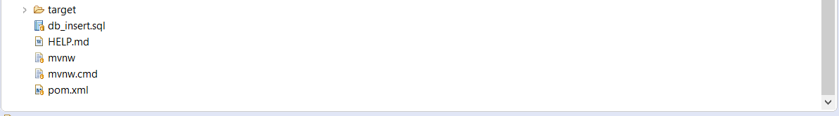

**Configuration du fichier POM.XML**

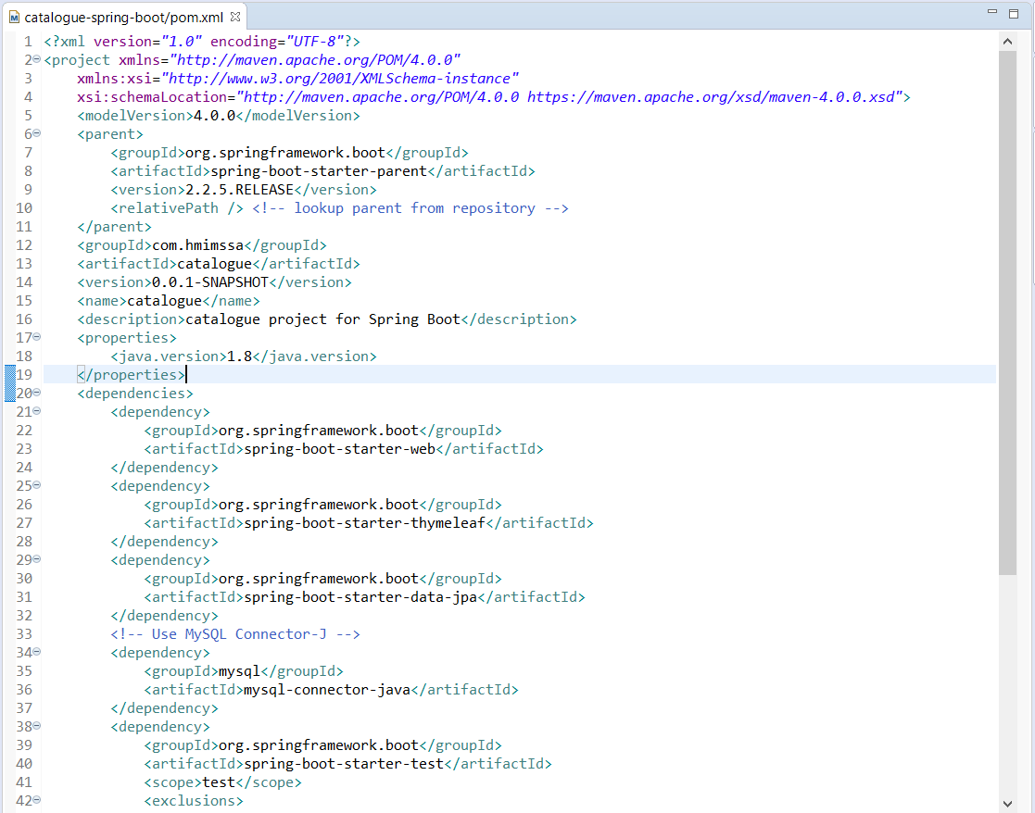

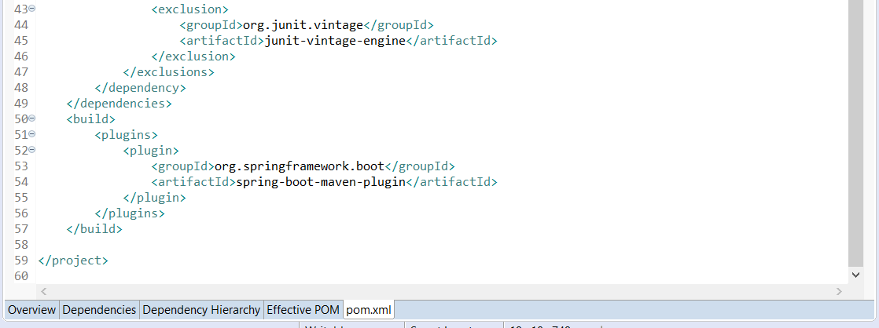

**Configuration du fichier application.properties**

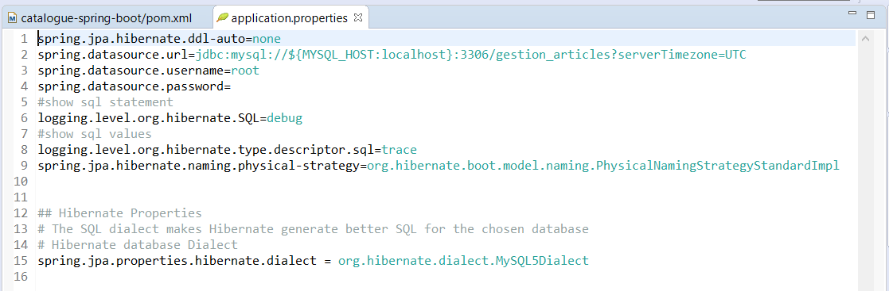

**Couche Controller**

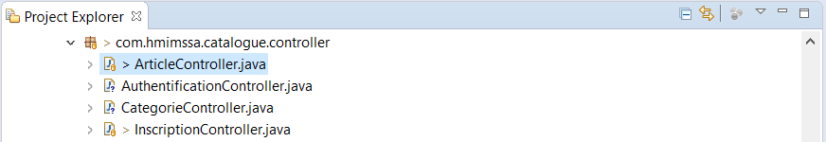

**Exemple contrôleur d'Article :**

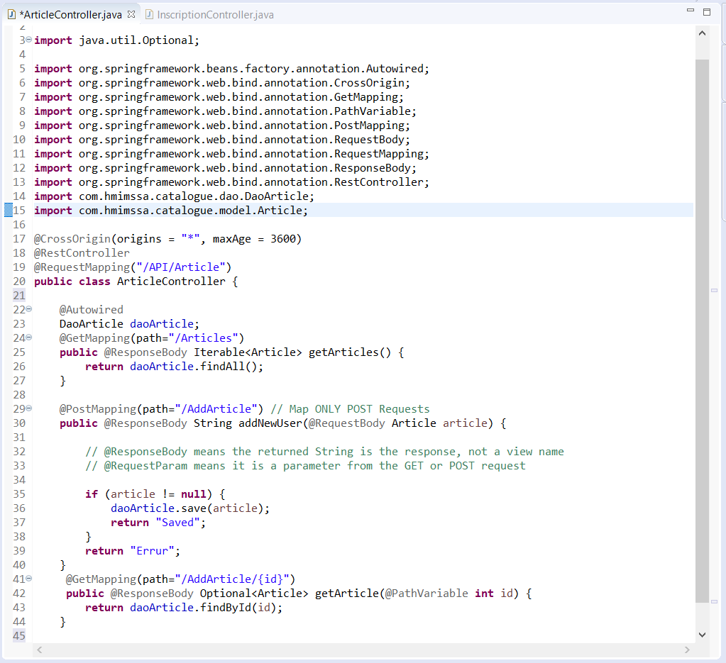

**Couche Dao**

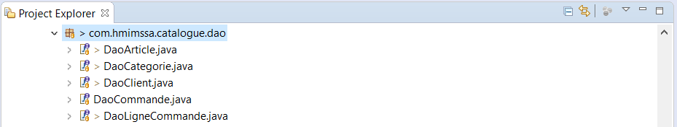

**Exemple :**

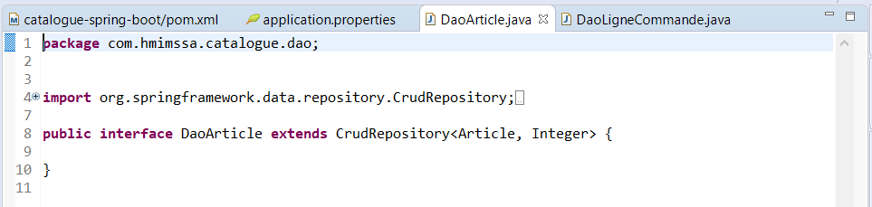

**Couche Métier**

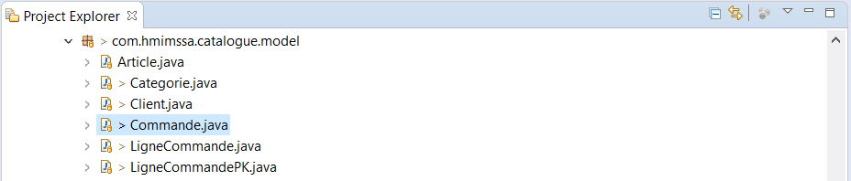

**Exemple de class commande de couche metier**

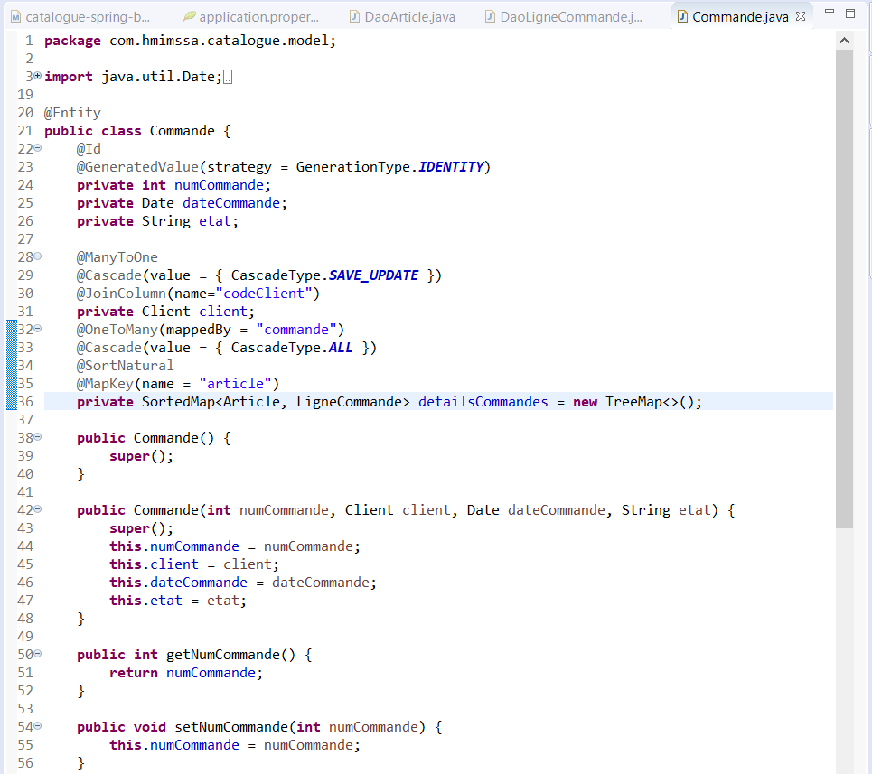

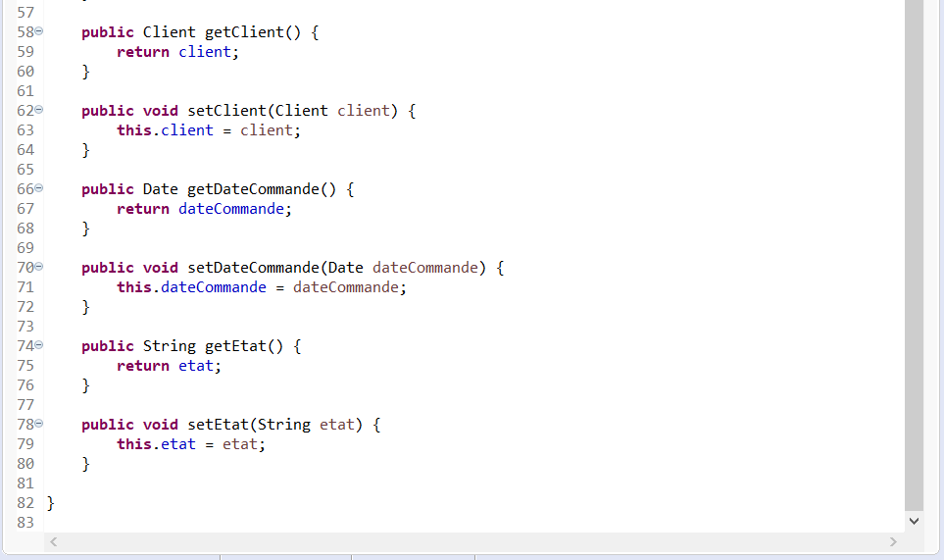

**Structure de Projet Front-end**

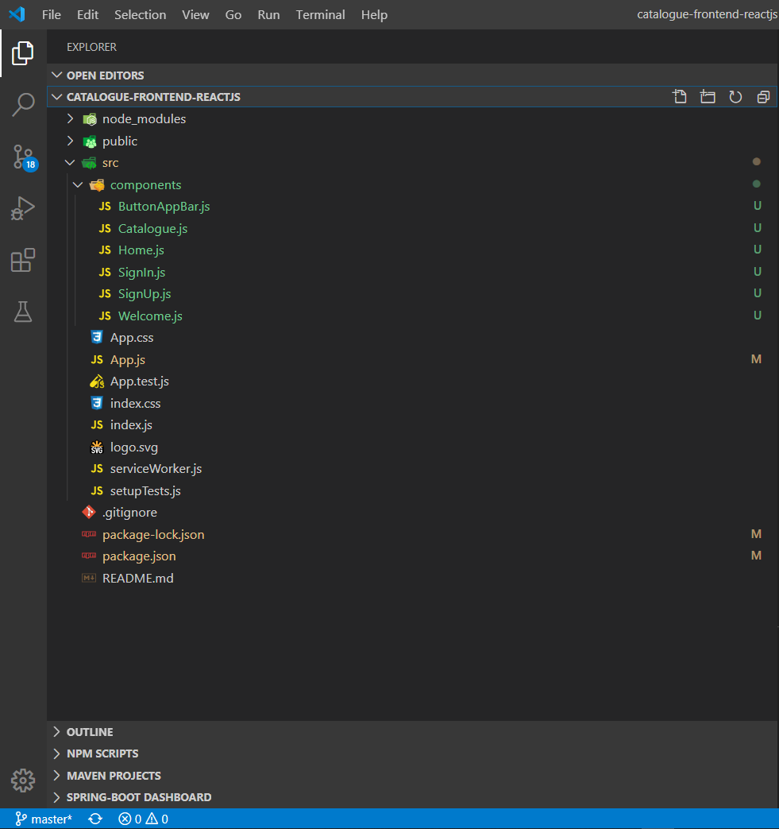

**Partie User Interface :**une page simple de présentation

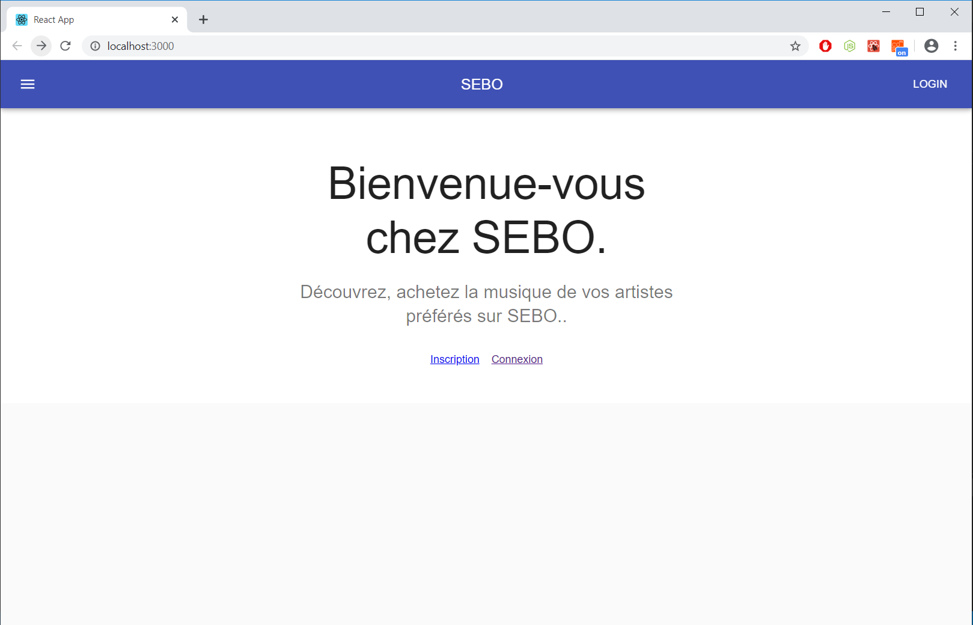

**Code :**

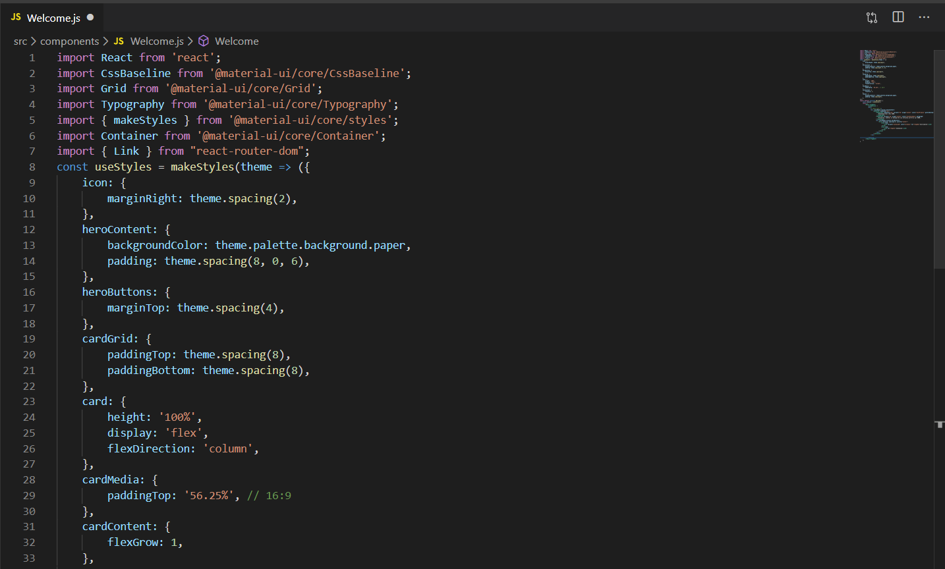

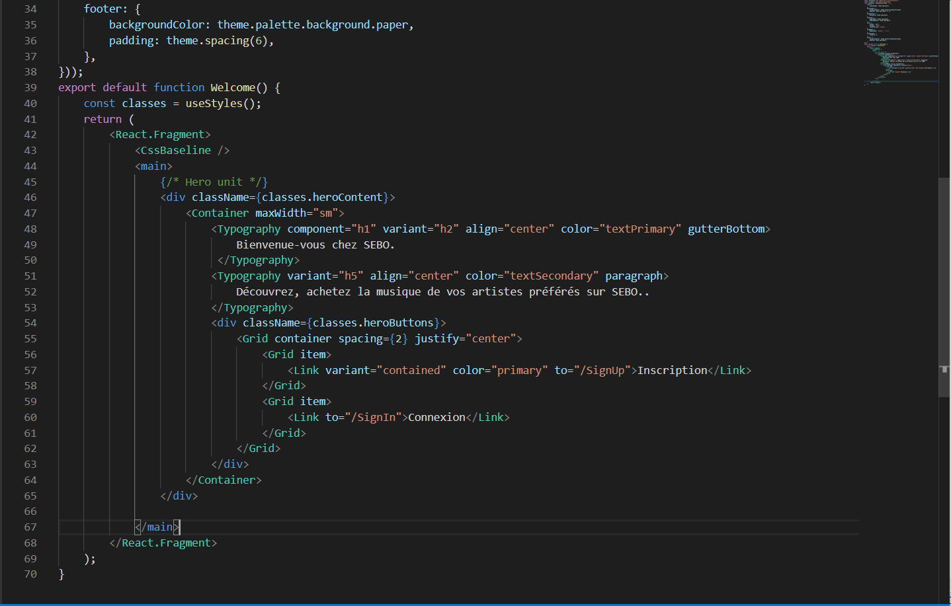

⮚ **Page d’authentification :**Dès l’accès à l’application une page d’authentification s’affiche.  
Après authentification accéder aux  
différentes fonctionnalités de l’site

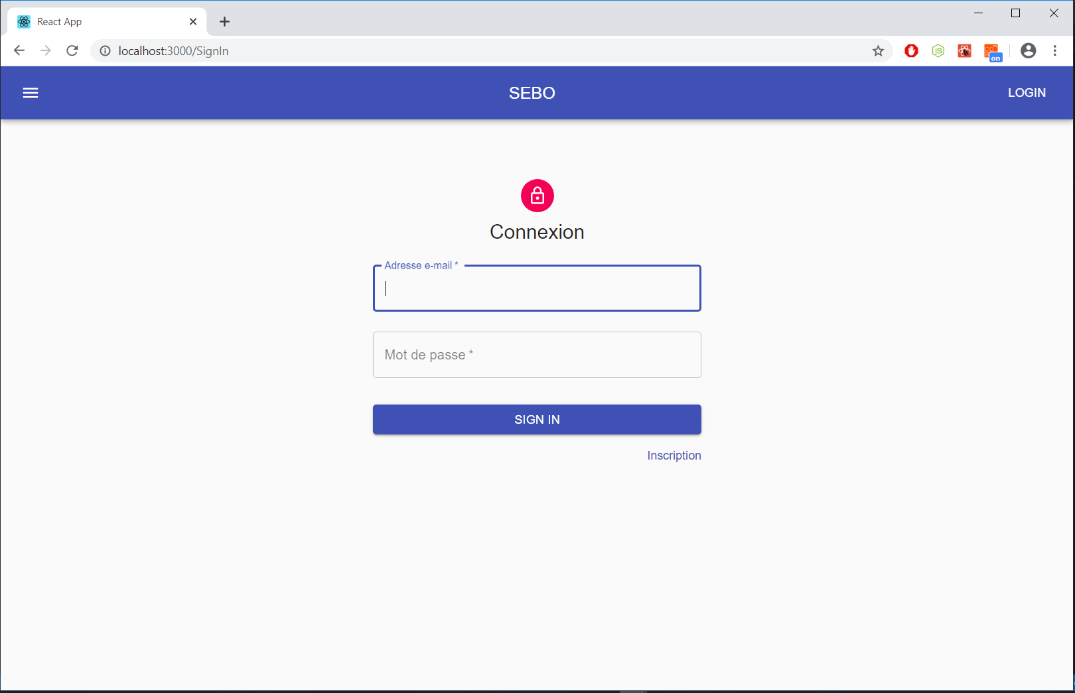

import React from 'react';

import Avatar from '@material-ui/core/Avatar';

import Button from '@material-ui/core/Button';

import CssBaseline from '@material-ui/core/CssBaseline';

import TextField from '@material-ui/core/TextField';

import Link from '@material-ui/core/Link';

import Grid from '@material-ui/core/Grid';

import LockOutlinedIcon from '@material-ui/icons/LockOutlined';

import Typography from '@material-ui/core/Typography';

import { makeStyles } from '@material-ui/core/styles';

import Container from '@material-ui/core/Container';

const useStyles = makeStyles(theme => ({

    paper: {

        marginTop: theme.spacing(8),

        display: 'flex',

        flexDirection: 'column',

        alignItems: 'center',

    },

    avatar: {

        margin: theme.spacing(1),

        backgroundColor: theme.palette.secondary.main,

    },

    form: {

        width: '100%', // Fix IE 11 issue.

        marginTop: theme.spacing(1),

    },

    submit: { margin: theme.spacing(3, 0, 2), },

}));

export default function SignIn() {

    const classes = useStyles();

    return (

        <Container component="main" maxWidth="xs">

            <CssBaseline />

            <div className={classes.paper}>

                <Avatar className={classes.avatar}>

                    <LockOutlinedIcon />

                </Avatar>

                <Typography component="h1" variant="h5">

                    Connexion

                </Typography>

                <form className={classes.form} noValidate>

                    <TextField variant="outlined" margin="normal" required fullWidth

                        id="email"

                        label="Adresse e-mail"

                        name="email"

                        autoComplete="email"

                        autoFocus

                    />

                    <TextField variant="outlined" margin="normal" required fullWidth

                        name="password"

                        label="Mot de passe"

                        type="password"

                        id="password"

                        autoComplete="current-password"

                    />

                    <Button type="submit" fullWidthvariant="contained" color="primary"

                        className={classes.submit}

                    >

                        Sign In

                    </Button>

                    <Grid container>

                        <Grid item xs>

                        </Grid>

                        <Grid item>

                            <Link href="#" variant="body2">

                                {"Inscription"}

                            </Link>

                        </Grid>

                    </Grid>

                </form>

            </div>

        </Container>

    );

}

⮚ **Page Inscription:**

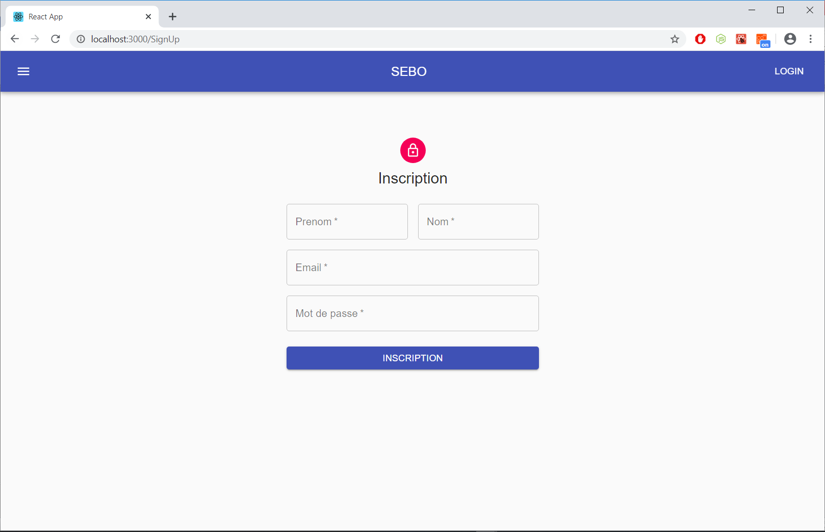

**Code :**

import React from 'react';

import Avatar from '@material-ui/core/Avatar';

import Button from '@material-ui/core/Button';

import CssBaseline from '@material-ui/core/CssBaseline';

import TextField from '@material-ui/core/TextField';

import Link from '@material-ui/core/Link';

import Grid from '@material-ui/core/Grid';

import LockOutlinedIcon from '@material-ui/icons/LockOutlined';

import Typography from '@material-ui/core/Typography';

import { makeStyles } from '@material-ui/core/styles';

import Container from '@material-ui/core/Container';

const useStyles = makeStyles(theme => ({

    paper: {

        marginTop: theme.spacing(8),

        display: 'flex',

        flexDirection: 'column',

        alignItems: 'center',

    },

    avatar: {

        margin: theme.spacing(1),

        backgroundColor: theme.palette.secondary.main,

    },

    form: {

        width: '100%', // Fix IE 11 issue.

        marginTop: theme.spacing(3),

    },

    submit: {

        margin: theme.spacing(3, 0, 2),

    },

}));

export default function SignUp() {

    const classes = useStyles();

    return (

        <Container component="main" maxWidth="xs">

            <CssBaseline />

            <div className={classes.paper}>

                <Avatar className={classes.avatar}>

                    <LockOutlinedIcon />

                </Avatar>

                <Typography component="h1" variant="h5">

                    Inscription

                </Typography>

                <form className={classes.form} noValidate>

                    <Grid container spacing={2}>

                        <Grid item xs={12} sm={6}>

                            <TextField autoComplete="fname"  name="firstName"

                                variant="outlined"

                                required

                                fullWidth

                                id="firstName"

                                label="Prenom"

                                autoFocus

                            />

                        </Grid>

                        <Grid item xs={12} sm={6}>

                            <TextField variant="outlined"  required fullWidth

                                id="lastName"

                                label="Nom"

                                name="lastName"

                                autoComplete="lname"

                            />

                        </Grid>

                        <Grid item xs={12}>

                            <TextField variant="outlined"  required  fullWidth

                                id="email"

                                label="Email"

                                name="email"

                                autoComplete="email"

                            />

                        </Grid>

                        <Grid item xs={12}>

                            <TextField variant="outlined"  required fullWidth

                                name="password"

                                label="Mot de passe"

                                type="password"

                                id="password"

                                autoComplete="current-password"

                            />

                        </Grid>

                    </Grid>

                    <Button type="submit"  fullWidth variant="contained" color="primary"

                        className={classes.submit}

                    >

                        Inscription

                     </Button>

                </form>

            </div>

        </Container>

    );

}

⮚ **Page Catalogue:**

